Vancouver Island Minor Lacrosse Commission
Regular Meeting Minutes
February 2, 2026

Attendees
Voting Executive
Chair Andy Stuart
Vice Chair Scott Barillaro
Secretary Krista Gregory
Treasurer Michelle Vecqueray
Zone 6 Representative Adam Gow
Web Master/Scheduler Liaison Jeremy Penzin (absent)
Female Coordinator Kate Blass

VIMLC Executive
BCLOA Representative Sarah Dmytruk
Indigenous Development Bryan Baxter
BCLCA Representative Kelly Fines

Association Representatives
Alberni Valley Dennis Bill
Campbell River Sarah Thomas
Comox Valley Chad Robinson
Cowichan Valley Janice Parmar, Koltin King
Juan de Fuca Kyla Pedlow, Nikila Cyr
Nanaimo Jesse Kemp, Shawn Swanson
Oceanside Ryan Minty
Peninsula Rod Senior, Terry Hall, Simon Upshon
Saanich Scott Barillaro, Katherine Dyrland
Victoria Esquimalt Kate Blass, Stacey Santos, Bryce Taylor

Other Attendees: Greg Toll, Cathy Coulson

- Call Meeting to Order 7:04 pm
Land Acknowledgement

- Adoption of Previous Minutes
Motion to accept the previous meeting Minutes made by Jesse Kemp, seconded by Koltin King, Carried

- Additions and Adoption of Agenda
- Motion to adopt the Agenda made by Kelly Fines, seconded by Sarah Dmytruk, Carried

- Business Arising from the Minutes none

- Financial Report: Michelle Vecqueray

Current Bank balance is $22,312.85 and there is 1 outstanding payment for an adjusted book balance of $22,072.85. There have been no changes to the bank account balance over the past month.
Attached is the proposed Budget for the 2026 season.
The Commission is in a strong financial position, seeing the overall cash balance growing modestly over the past few seasons.
The budget includes increases to the scheduler contract, playoff referees to allow for 3 official system during playoffs, and an increase to Google Drive/meeting fees.
Please review the complete budget and individual line items for any changes noted or anticipated for the 2026 season.
Over the past several seasons we have also charged $15 per player to the associations.
Based on the current financial situation my recommendation is that we decrease this amount to $12.50 per player. The presented budget is prepared with this reduced fee of $12.50.
Based on this presented budget, we would anticipate a year-end bank balance of $16,290.00

Motion to approve the Budget with a $12.50 fee per player for the 2026 season made by Sarah Thomas, seconded by Simon Upshon, Carried

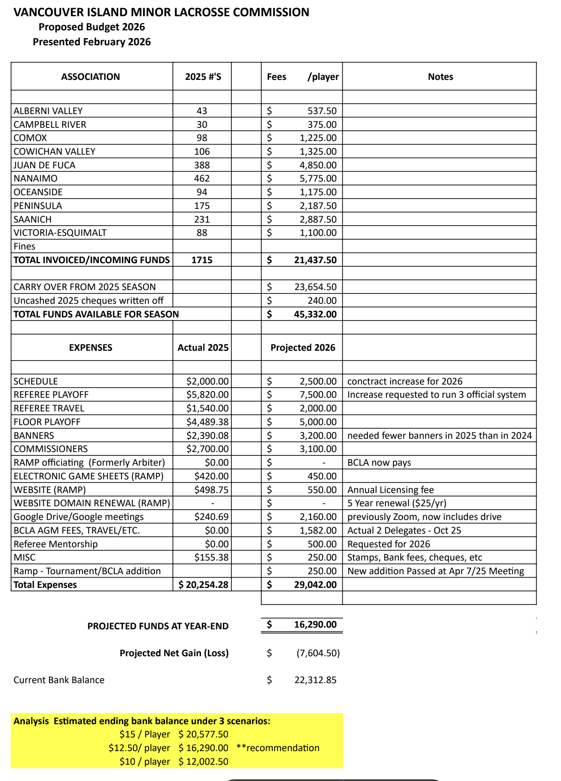

- Zone 6 Reports
- Chair Andy Stuart
- 2026 Scheduler - We have entered into a contract with Jenn Lambert to be the 2026 Scheduler. Jenn has been the scheduler the last two seasons. Scott Barillaro and Jenn will be setting up a virtual meeting with all floor allocators to ensure we are being efficient with the very limited floor time we have this season.
- 2026 Playoffs - We have booked Kerry Park for the weekends of June 12 - 14, June 19 - 21, June 26 - 28 and July 3 - 5, 2026. Fridays at 7pm until 9:30pm and Saturday & Sunday from 830am until 6pm.
- Our meeting discussion point will be the number of games for each division. For the older divisions we can focus on how this factors into tournaments, academy teams and Team BC Tryouts. I really like how we had productive discussions last meeting and hope to continue this venue for productive conversations between associations.

- Minor Directorate Rep Adam Gow
It was suggested that associations look into Directors Insurance if they do not already have it. Largely to cover individuals from lawsuits following board rules. Many already have but some don’t.
Coach’s group has confirmed existing and new coaches requiring “making ethical decisions” (MED) will continue to be able to do so online.
March 1 is the deadline for VIMLC to have commissioners named to MD for a ratification vote on March 12. If you have not already submitted a name please do so.
The question was raised if associations would be interested in considering a U5 division. This is entirely unofficial and more of a search for interest. Currently the BCLA is not considering the division, the question is being asked seeking interest at the club level. If enough interest then the BCLA could be asked to cover U5 under bylaws and insurance. This would likely end up being an inhouse division.
The MD may meet in February to discuss the updated rules.
New rule books are being made and will be available for purchase or download, this was stated before the CL rule update so will need to find out if it will include updated rules or not.

- Vice Chair Scott Barillaro
Main focus for the past month has been business rules and getting scheduler contract in place. Andy noted those in his report. I understand that some of you may not have received the business rules when I resent them. I will send them out again today. We can accept feedback a bit later if necessary.

I reached out to mainland Presidents (in my other capacity) and got the dates they requested for the major tournaments island teams typically attend. We can combine this with other information received regarding spring field team travel dates and TeamBC blackouts and map it against available dates to see what it looks like. I would prefer to build constraints in at the planning stage rather than produce a schedule that needs to change two weeks later once teams know what tournaments they will attend. We won't be able to catch everything, but hopefully it will reduce work for Commissioners and teams if we consider some of it.

Generally, it is great to see membership growth in different areas. That said, more teams means more demand on floor time when availability seems to be going in the opposite direction for many associations. This will impact the number of games we can schedule at each age group. I plan to work with Jenn to do some analysis on floor time requirements per team. That will inform the discussion with floor allocators at the meeting we will have this month. I can speak a bit more about this tonight.

- BCLCA Rep Kelly Fines
Nothing to report

- BCLOA Rep Sarah Dmytruk
At this time, we have no set dates for referee clinics however it is safe to expect they will be taking place early to mid March as the Learning Facilitators do not have their training until February 28th. I am hoping to have dates for the clinics in the next few weeks.

- Indigenous Development Coordinator Bryan Baxter
Nothing to report

- Female Coordinator Kate Blass
The Island representatives for the female divisions met last week with Pam Mason and John Hamilton to discuss this season's interlocking schedule. We discussed the floor shortage on the island and the challenges all associations with female teams face when allocating game time. We will look at sharing floors and utilizing mid island locations like Oceanside where possible. A big thanks to Cathy Coulson for finding potential solutions to some of these issues.

- Web Master Jeremy Penzin
No report

Motion to accept zone reports as presented made by Koltin King, seconded by Sarah Thomas, Carried

- Association Reports

- Alberni Valley

Recruitment & Registration
Our elementary school "try-it" sessions (Grades 1–5) and Monday night free sessions at the Glenwood Centre have resulted in significant community exposure to youth learning lacrosse. These efforts are successfully driving registrations for our U7, U9, and U11 teams. I had an interview with AV news last week, so further lacrosse education is expected to be in the newspaper this week.
Team Compositions
Currently, we are anticipating lower numbers in the U11, U13, and U17 divisions. To ensure these players have a season, we have contacted Ryan at Oceanside Lacrosse to explore options for combined association teams.
Upcoming Events
Tomorrow is a significant day for our outreach; Darren Mannix is scheduled for five P.E. classes at Ecole Alberni Elementary, followed by our Glenwood try-it session from 5:00 PM – 6:00 PM. We have a 2-day lacrosse camp occurring on March 16 and 17 during spring break to allow new and returning players to shake off the rust and get ready for a fun and exciting season.
Officiating
We are proactively reaching out to minor hockey referees and previously certified officials to ensure we have sufficient coverage for officials for the U13, U15, and U17 games this season.
- Campbell River
We’ve been given the green light for April floor time. Which is a relief. Unclear if we have floor for the entire season but it’s a start! Still waiting on other contract requested months so we can present that to the scheduler. I will bug them again this week

With the arena and our outdoor box issues, we will start the process on asking the city for upgrades to utilize the outdoor box during our arena upgrades next season.
We will be looking for sponsors and a lot fundraising and being more involved in the community. Will hopefully get more eyes on lacrosse here
Our numbers are low but higher than last year at this point.

- Comox Valley
Our registration opened on January 15, we have 61 players registered to date. Our numbers are healthy in U11, U13 and U15 but we may not have enough to field a U17 team this season.

We started our "learn lacrosse" program last week in partnership with the school district here. Coaches and older players will spend a morning at an elementary school teaching lacrosse during their PE block. It's focused on grades K-4 and they should see about 1000 kids over the 8 weeks. We also begin hosting evening drop in sessions for new and returning players this month.

Head coaches are in place for all teams and we have a good number of young and veteran officials returning this year.

- Cowichan Valley
Cowichan has nothing to report. Registration is slow this year with ball hockey starting in the Cowichan valley.
We will not have a u17 or u22 female team this year and are hopeful to have teams in every other division

- Juan de Fuca
JDF registrations are in a very strong position this season. We are currently very close to our total registration numbers from last year and expect to meet or exceed those numbers as registrations continue to trickle in.
U15 registration is now closed, as we have reached capacity with two full teams. U13 and U17 are also approaching that point and may need to close in the near future as well.
At U13, JDF will have four teams this season. Similar to Nanaimo, we are working through tiering questions in this division. Our strong preference is to offer A1, A2, B, and C teams. From past experience, balancing two B teams has proven extremely difficult and often results in uneven competition and disappointment. Additionally, having two JDF teams consistently play each other in competitive divisions runs counter to the spirit and culture we are trying to build within our association.
U17 will field three teams this season. We are still working through the appropriate tiering for those teams and expect to have more clarity shortly.
At U9, we are awaiting confirmation on whether the division will operate full-floor 5v5 or half-floor 3v3, as this decision will directly impact the number of teams we are able to form.
We have also received interest in hosting Sooke-specific teams at U7 and U9. These teams would practice in Sooke at the outdoor box while playing games at the JDF box. This will also be dependent on what is decided for U9.
Team formation is complete for both U15 teams, two of the four U13 teams, and two U17 teams. Our focus will soon shift to U11 and younger divisions.
It has been great to hear about the various “grow the game” initiatives being used by other associations. While this is something JDF has discussed, we are currently very limited by available practice floor time and are effectively maxed out with the number of teams we can reasonably support this season.

- Nanaimo
Our association is close to surpassing last year's registration record of 462 players. We are currently at 458, with more registrations still coming in.
We recently delivered a Try Lacrosse program and shared a promotional flyer with the school district, which was distributed to all school principals. The flyer highlighted the Indigenous roots of the game and its significance as Canada’s national summer sport. More than 50 youth participated in the event. We used soft balls, provided basic sticks, and ensured parents had information about schedules and available financial assistance. The event has resulted in 10 new player registrations so far.
Our growing numbers have created some scheduling challenges related to floor time. Teams will be sharing the floor, and we will be using all available space. We have completed our declaration forms for team numbers in each division, but we are looking for guidance on tiering, especially at U13 coed. We will have four U13 Coed teams this season, and while evaluations will guide player placement, decisions by other associations will influence how we align tiering. Are other associations planning to tier at the C level? We want to ensure meaningful competition and avoid lopsided results.
In our female program, we have noticed a shift among younger athletes who are choosing to register for coed because it offers significantly more games on the island. With this in mind, our association is seeking clarification and updates.
- Clarification: If a female player is registered in coed, is she considered a call up when she plays the same level in female? For example, if a player registered in U13 B coed is asked to play U13 B female, is that viewed as a call up, or can she participate in both without restriction?
- Updates: At our last meeting, a strategy was outlined for growing the female game on the island, starting with U11 female and assigning a female development board member. Have any associations taken these steps, and if not, what additional support might be helpful?
Lastly, we are preparing for our in-house coaching symposium. This event brings our association’s coaches together to learn from one another, connect with referees, and work toward elevating the overall standard of coaching. We will also use the session to communicate any rule updates from the CLA presentation and to review topics such as crease dives. We are looking forward to a strong season ahead.

- Oceanside
We are off to the races with registration of a total of 75 so far . It’s looking like we will have 1 - u7/u9 . 2 u11 teams which is a first for us in very long time .1- u15 team. U13 and u17 is looking to be a mixed team with port Alberni . Which Iv bin in contact with Jeremy (port president) .

It seems to happen every year in our area that a later wave of registration happen . Hockey parents still in hockey mode I guess . So very hopeful that happens very soon and before end of February . We pushing try lacrosse in a few of the elementary schools . Aswell every Monday for all age groups at a local gym.

It’s looking like our outside box is gonna have an overhaul . Which is great but not gonna have practice area . Our ice is sappose to come out April 12/26 but if the jr hockey team goes deep in playoffs then ice stays in . There isn’t a rock solid date on construction of box . But we are going to be practicing at arbutus meadows . A multi sport facility until ice comes out . Not the greatest but gotta do what we gotta do .

Head coaches aren’t solidified yet but still in application process and have a pretty good idea of who is gonna take the reins for each team .

- Peninsula
We currently have 136 registered players and are projecting a total of 12 teams this season, up from 10 teams last year.
Last week, we introduced lacrosse to every class at Sidney Elementary School. The response has been very positive, and we have already received inquiries from two additional elementary schools interested in having us facilitate similar sessions. We were also fortunate to have a female lacrosse player from Langford travel out to assist, and she made a strong, positive impact with the students.
Scheduling has been particularly challenging this season, and we are still working to secure sufficient floor time. Additional meetings are scheduled to address this issue, and we are hopeful it will be resolved in a timely and constructive manner.
Work is also underway to make improvements to our operating policies.
- Saanich
We have a total registration of 218 players including females which will play at VELA. This is 12 below our total registration from last season so I expect we will be able to get past that by the time the season starts. We closed U17 registration due to demand, but other age groups remain open.

We plan for two teams at U17, two teams at U15, two teams at U13 and three teams at U11 (including a U11A team). We will have two U9 teams if we play full floor or three if we play half floor. We should have one U7 team based on current registration. Team selection is complete for U11A, U13A and U15A. Team selection for U17A should be finished this weekend.

We will now turn to some business and other pre-season planning activities including implementing an updated Social Media Policy, launching an online team store, coach development and goalie development sessions between now and the end of March.

- Victoria Esquimalt
Nearly all of our competitive coed divisions have been released. It was definitely tough because our numbers were decent this season. We will host U7 and U9 at home as they are able to play all games outside. We are working to get into local schools in Feb. Archie Browning's upgrades are set to be completed before next season.

There are currently 105 girls registered which matches last season's numbers. We have another 10-15 attending drop ins that have not registered yet. We are in the bubble year where the numbers spread awkwardly across divisions which will create some challenges with team composition. We are planning to push registrations one more time. We've secured time at Panorama, Centennial Park, and Fuller Lake so far to accommodate some games. The ability to host all of the girls really hinges on what Kerry Park decides to give us since all associations in and around Victoria are fighting for floor time this season.

Motion to accept association reports as presented made by Jesse Kemp, seconded by Adam Gow, Carried

- Commissioner Reports
No reports at this time

- New Business
- Scheduler Contract
The VIMLC has re-engaged Jenn Lambert to create the schedule for the 2026 season. The budget provides for an increase in the stipend to $2500, paid in 3 installments
There will be a virtual meeting for all association floor allocators with Jenn and Scott Barillaro, please ensure contacts are up to date for that position on association websites.

- Business Rules
The document was resent to presidents earlier this week, please us the Google link to provide feedback. We will vote on approving these rules at the March meeting.

- Commissioners
February 10 is the latest date to submit association nominees for this position so that the information can be given to the BCLA

- Preliminary Declarations
Associations presented their preliminary registration numbers and plans for team composition in each division.
- Release Process
The process has occurred earlier this season as Vela is not able to host teams because of arena closure. Please continue to submit Release Requests and Playdown Requests to Krista via email.

- Saanich Vela U11 Combo Team
Vela is not able to host co-ed teams this year because of arena closure. Older players have been released to other associations, but Vela and Saanich would like to combine their U11 players into 3 teams.
Motion: To allow Vela and Saanich to combine their U11 players to form 3 teams made by Andy Stuart, seconded by Krista Gregory, Carried

- Rule Changes MD Direction
The CLA introduced some significant rule changes at the end of January. The Minor Directorate created a side by side comparison of the old and new rules which they submitted to the BCLCA, BCLOA and BCLA. We will have to wait to on the MD decision on what is practical to implement this season and adjust as needed. It is recommended that associations begin to budget for expenses related to the rule changes, like larger nets. For next meeting, all presidents please take an inventory of the nets you already have.

- Discussion Topic: Number of games and floor time
Feedback was provided by associations and commissioners about last season, highlighting what worked well and providing suggestions.

- Next Meeting: Monday, March 2 at 7 pm

- Motion to Adjourn at 8:25 pm made by Greg Toll, seconded by Kyla Pedlow, Carried

